M.C.E Society’s
Abeda Inamdar Senior College of Arts, Science and Commerce (Autonomous), Pune-1
Department of BCA Science


A PROJECT REPORT ON
“Fraud Detection using Machine Learning”

AT
CodSoft

SUBMITTED TO
SAVITRIBAI PHULE PUNE UNIVERSITY
IN PARTIAL FULFILLMENT OF
BACHELOR OF COMPUTER APPLICATION (Science)

SUBMITTED BY
Shaikh Aliya Alim (2025-26)

UNDER THE GUIDANCE OF
Prof. Veena Gandhi

(March-2026)
M.C.E Society’s
Abeda Inamdar Senior College of Arts, Science and Commerce (Autonomous), Pune-1
Department of BCA Science


A PROJECT REPORT ON
“Fraud Detection using Machine Learning”

AT
CodSoft

SUBMITTED TO
SAVITRI BAI PHULE PUNE UNIVERSITY
IN PARTIAL FULFILLMENT OF
BACHELOR OF COMPUTER APPLICATION (Science)

SUBMITTED BY Shaikh Aliya Alim (2025-26)

UNDER THE GUIDANCE OF
Prof. Veena Gandhi

(Internal Examiner) (External Examiner) (IT expert)


INTERNSHIP OFFER LETTER


INTERNSHIP COMPLETION LETTER

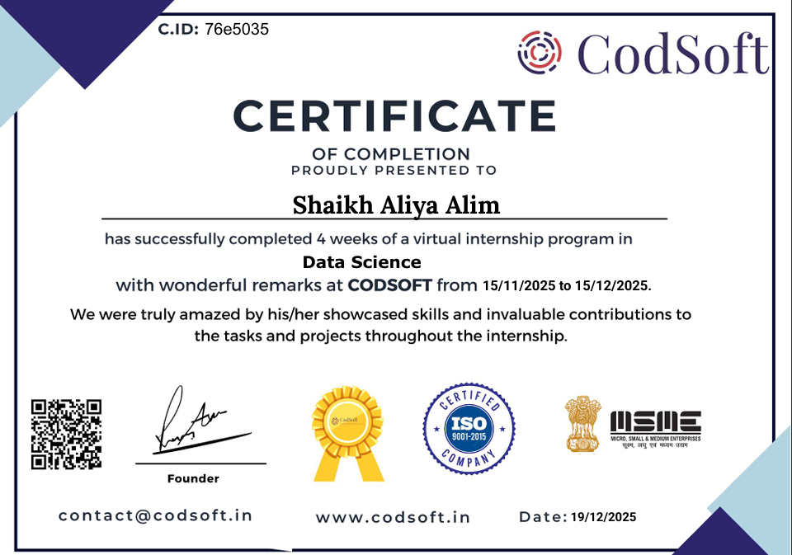

DECLERATION

I, Shaikh Aliya Alim, hereby declare that the ON-THE-JOB (OJT) titled “Fraud Detection using Machine Learning” is my original work and has been conducted in accordance with the guidelines and
Regulations of Savitribai Phule Pune University (SPPU).
I confirm that:
1. The work presented in this project is my own, and any assistance received in preparing
This research project has been acknowledged.
2. All sources of information, data, and literature used have been appropriately cited and
Referenced.
3. I have not engaged in any form of plagiarism, and I understand the consequences of
Academic misconduct.
4. The ON-THE-JOB (OJT) has not been submitted for any other degree or qualification at this university or any other institution.
5. I have followed the ethical guidelines and procedures laid out by the university and
obtained all necessary approvals and consents for the work.
6. I understand that the university / institute reserves the right to review and scrutinize the
project for authenticity and originality.
I hereby give my consent for this On-The-Job (OJT) report to be used for academic purposes,
including publication and sharing within the academic community.
Student’s Signature: _______________________________
Date: _____________________________
Faculty Guide’s Approval:
I hereby certify that I have reviewed the On-The-Job (OJT) titled “Fraud Detection using Machine Learning” and
confirm that it meets the standards and requirements set forth by Savitribai Phule Pune
University (SPPU).
Guide’s Name: Mrs. Veena Gandhi
Guide’s Signature: ____________________________________
Date: __________________

ACKNOWLEDGEMENT

I would like to express my heartfelt gratitude to all those who contributed to the successful completion of my On-The-Job Training (OJT), conducted from November to December 2025, as part of the BCA program requirements.
First and foremost, I extend my sincere thanks to my faculty mentor, Mrs. Veena Gandhi, for their invaluable guidance, continuous support, and insightful feedback throughout this project. Their encouragement and constructive suggestions played a crucial role in shaping the direction and quality of my work.
I am deeply grateful to the respondents of this OJT for their cooperation and willingness to share their time, knowledge, and resources. Their support provided me with practical exposure and greatly enriched my understanding of real-world business practices.
I also sincerely appreciate the support of the Head of Department, faculty members, and batch mates whose assistance and encouragement facilitated the smooth conduct of this project.
Lastly, I wish to thank my family and peers for their patience, motivation, and moral support throughout this journey. This OJT has been an enriching learning experience, and I am sincerely thankful to everyone who contributed in any way.
Shaikh Aliya Alim
BCA [2025 -2026]
AISC

INDEX

Table of Content
Chapter | Content | Page no
1 | Introduction  - Abstract  - Problem Statement  - Purpose ,Objective  - Vision  - Mission  - Goals
2 | Company Overview  2.1 Company Introduction  2.2 Company Services  2.3 Mission, Vision, and Core Values
3 | Training Objectives  3.1 Overall purpose of the OJT training  3.2 Aims to achieve by completing the program.
4 | Tasks Allotted  4.1 General overview of duties and responsibilities  4.2 Tasks done regularly (daily/weekly)  4.3 Duration of assignment
5 | System Analysis & Design (Flowchart or UML Diagrams)  5.1 Configuration (Hardware)  5.2 Software (Tools)  5.3 Flowchart / UML
6 | Input /Output Screen
7 | Skills Developed / Learning Outcomes  7.1 Technical Skills Acquired  7.2 Problem-Solving and Critical Thinking  7.3 Learning Outcomes
8 | Challenges Faced  8.1 Understanding Existing Systems  8.2 System Complexity and Integration  8.3 Adapting to New Technologies and Tools
9 | Conclusion
10 | References / Bibliography  Include any textbooks or reference books you used for understanding your tasks.

CHAPTER 1: INTRODUCTION
  - Abstract
In the modern digital era, online transactions and digital payment systems have become an essential part of daily life. Credit cards are widely used for online shopping, bill payments, fund transfers, and other financial activities. However, with the increasing usage of digital transactions, the risk of credit card fraud has also increased significantly. Fraudulent transactions cause major financial losses to banks, financial institutions, and customers.
Traditional fraud detection systems are mostly rule-based and depend on predefined conditions. These systems are not always efficient because fraud patterns continuously change. Therefore, there is a strong need for an intelligent system that can automatically detect fraudulent activities based on transaction patterns.
This project focuses on developing a Credit Card Fraud Detection System using Machine Learning techniques during the internship at CodSoft. The system analyzes historical transaction data and classifies transactions as fraudulent or genuine. Various classification algorithms were implemented and compared, and after performance evaluation, the K-Nearest Neighbors (KNN) algorithm was selected as the final model. The project includes data preprocessing, feature scaling, model training, model evaluation, and saving the trained model for future use.
This project provided practical exposure to real-world data handling, machine learning model development, and performance analysis.

  - Background of the Study
The rapid advancement of technology has transformed the banking and financial sector. Today, digital payment systems such as credit cards, debit cards, UPI, and online banking are widely used. While these systems provide convenience and speed, they also increase the chances of cybercrime and fraudulent activities.
Credit card fraud occurs when an unauthorized person uses someone else's credit card information to perform illegal transactions. Fraudsters use different techniques such as phishing, identity theft, and data breaches to obtain card details. Detecting such fraud manually is very difficult due to the large volume of daily transactions.
Machine Learning has emerged as a powerful tool for fraud detection. It allows systems to learn from historical data and identify patterns that indicate suspicious activity. Unlike traditional systems, machine learning models can adapt to new fraud patterns over time.

In this project, a real dataset containing credit card transactions was used.
The dataset includes both genuine and fraudulent transactions.
Since fraud cases are very rare compared to genuine transactions, the dataset is highly imbalanced.
Handling such imbalanced data is one of the major challenges in fraud detection.
This project uses supervised learning techniques to classify transactions. The system learns from labeled data and predicts whether a new transaction is fraud or not.
In addition, fraud detection systems must handle highly sensitive financial data. Therefore, data security and confidentiality are extremely important. Machine learning models must be trained carefully to avoid bias and overfitting. Proper validation techniques such as train-test split are necessary to ensure that the model performs well on unseen data.
Supervised learning algorithms such as Logistic Regression, Decision Tree, Random Forest, and K-Nearest Neighbors are commonly used for classification problems. In this project, multiple models were tested and compared to find the best performing algorithm for fraud detection.
The success of a fraud detection system depends not only on accuracy but also on precision and recall. In fraud detection, recall is very important because missing a fraudulent transaction can cause financial loss. Therefore, performance metrics were carefully analyzed during this project.

  - Problem Statement

Credit card fraud detection is a challenging problem due to several reasons:
- A large number of transactions are performed every day.
- Fraudulent transactions represent only a small percentage of total transactions.
- Fraud patterns change frequently.
- Manual monitoring is time-consuming and inefficient.
- High false positives can disturb genuine customers.
Another major issue in fraud detection is the imbalance in data distribution. Since fraudulent transactions are very rare compared to genuine transactions, the model may become biased toward predicting most transactions as genuine. This can reduce the effectiveness of the system.
Therefore, careful preprocessing, feature scaling, and proper evaluation metrics are required to ensure balanced and fair model performance. The system must be able to correctly identify fraud cases without disturbing genuine users.

Because of these challenges, financial institutions require an automated and intelligent system that can accurately detect fraudulent transactions while minimizing errors.
The main problem addressed in this project is:
“To develop a Machine Learning-based model that can effectively detect fraudulent credit card transactions with high accuracy and reliability.”

  - Purpose and Objectives of the Project

Purpose
The main purpose of this project is to design and implement a machine learning-based fraud detection system during the internship at CodSoft. The system should automatically analyze transaction data and classify transactions as genuine or fraudulent.
The project aims to improve fraud detection efficiency and reduce dependency on manual monitoring systems.

Objectives
The key objectives of this project are:
- To study the concept of credit card fraud and its impact.
- To understand the structure and features of the transaction dataset.
- To perform data preprocessing such as handling missing values and feature scaling.
- To split the dataset into training and testing sets.
- To implement classification algorithms for fraud detection.
- To evaluate models using performance metrics such as accuracy, confusion matrix, precision, recall, and ROC curve.
- To perform hyperparameter tuning for improving model performance.
- To select the best performing model (KNN).
- To save the trained model and scaler using joblib for future predictions.
Apart from technical implementation, this project also focuses on understanding real-world business problems in the financial sector. Fraud detection is not only a technical challenge but also a security and trust-related issue.

Banks and financial institutions depend on such intelligent systems to maintain customer confidence.
Through this internship at CodSoft, the objective was not only to build a model but also to understand the complete lifecycle of a machine learning project, including data collection, preprocessing, training, evaluation, tuning, and deployment preparation.

  - Vision and Mission

Vision
In today’s rapidly growing digital economy, financial transactions are increasing at an exponential rate. With this growth, the risk of cyber fraud and financial crimes has also expanded significantly. The long-term vision of this project is to contribute toward building secure and intelligent financial systems that can automatically detect and prevent fraudulent activities.
The vision also focuses on promoting the use of Artificial Intelligence and Machine Learning in enhancing digital security. By developing intelligent systems capable of identifying suspicious patterns, financial institutions can reduce losses and improve customer trust. This project aims to demonstrate how data-driven technologies can strengthen cybersecurity frameworks.
Furthermore, the vision extends toward creating scalable and adaptable fraud detection systems. As fraud patterns continuously evolve, future systems must be capable of learning and adapting dynamically. This project lays a foundational step toward building such intelligent and adaptive systems.
Another important aspect of the vision is to encourage the integration of machine learning models into real-time transaction monitoring systems. In real-world applications, fraud detection systems must process thousands of transactions per second. Therefore, the long-term vision includes developing optimized and efficient models that can operate in real-time environments.

Mission
The mission of this project is to apply supervised machine learning algorithms to analyze transaction data and build an efficient classification model. The project focuses on improving detection accuracy while minimizing false positives, ensuring both security and customer satisfaction.
The mission of this project is not limited to building a classification model but also to understand the complete lifecycle of a machine learning-based fraud detection system. The project focuses on systematic implementation, careful evaluation, and performance optimization to ensure reliable results.

The project also aims to build awareness about the importance of ethical data usage and secure handling of sensitive financial information. Since fraud detection involves confidential transaction data, maintaining privacy and integrity is an essential part of the mission.

Additionally, this project’s mission includes continuous learning and improvement. Machine learning models must be updated and retrained regularly to adapt to new fraud patterns. Therefore, the project promotes research-oriented thinking and openness to exploring advanced techniques such as deep learning and ensemble models in the future.
Overall, the mission is to develop a practical, efficient, and scalable fraud detection solution while strengthening technical knowledge, analytical ability, and professional skills required in the field of Data Science and Artificial Intelligence.
  - Goals of the Project

The primary goals of this project are:
- To build a practical understanding of machine learning concepts through real-world implementation.
- To design a classification model capable of identifying fraudulent transactions.
- To compare different models and select the most suitable one.
- To improve prediction performance through hyperparameter tuning using GridSearch.
- To reduce the rate of false positive predictions.
- To save and reuse the trained model for future predictions.
- To gain hands-on experience in working with Python libraries such as Pandas, NumPy, Scikit-learn, and Matplotlib.
- To complete the internship project professionally under the guidance of CodSoft.

Another important goal of this project is to enhance analytical and problem-solving skills. Working on real datasets improves understanding of data patterns and model behavior. The project also aims to strengthen programming skills in Python and improve knowledge of machine learning libraries.
Furthermore, the project encourages continuous learning and exploration of advanced techniques that can be applied in future projects such as deep learning-based fraud detection systems and real-time fraud monitoring.

CHAPTER 2 : COMPANY OVERVIEW

2.1 Introduction to CodSoft

CodSoft is a technology-driven organization that provides internship programs and skill development opportunities in various technical domains. The organization focuses on enhancing students practical knowledge by offering project-based internships in emerging technologies.
In today’s competitive world, theoretical knowledge alone is not sufficient to succeed in the IT industry. Companies expect candidates to have practical exposure and hands-on experience. CodSoft plays an important role in bridging this gap between academic learning and industry requirements.
CodSoft provides structured internship programs where students are assigned real-world projects. These projects help interns understand industry standards, coding practices, and real-time problem-solving approaches. The internship programs are designed to enhance analytical thinking, programming skills, and confidence among students.
During my one-month internship at CodSoft, I worked on a project titled “Credit Card Fraud Detection Using Machine Learning.” This project provided me with practical exposure to data preprocessing, model building, performance evaluation, and model deployment preparation.

2.2 Vision of CodSoft
The vision of CodSoft is to become a leading platform for technical education and practical .learning. The organization aims to empower students by equipping them with industry-relevant skills that prepare them for real-world challenges.
CodSoft envisions creating a strong community of skilled professionals who are capable of developing innovative and efficient technological solutions. The organization believes in continuous growth, learning, and adaptation to new technologies.
By focusing on modern domains such as Artificial Intelligence, Machine Learning, Data Science, and Web Development, CodSoft aims to prepare students for the future of technology.

2.3 Mission of CodSoft
The mission of CodSoft is to provide quality internship programs that focus on practical implementation of concepts rather than only theoretical understanding.
The key missions of the organization include:
- Providing hands-on project experience to students.
- Enhancing technical and programming skills.

- Encouraging logical thinking and analytical ability.
- Preparing students for job-oriented roles in the IT sector.
- Promoting innovation and creativity in technology.

CodSoft ensures that interns are guided properly throughout the internship period and complete their assigned tasks successfully.

2.4 Core Values of CodSoft
- CodSoft operates based on strong core values that guide its working culture and internship programs. These core values include:
- Learning and Development – Continuous learning is encouraged to keep up with technological advancements.
- Innovation – Interns are motivated to think creatively and develop innovative solutions.
- Integrity – Ethical practices and honesty are maintained in all activities.
- Quality – Focus on delivering high-quality project work.
- Collaboration – Teamwork and mentor support are emphasized during internships.

These values help maintain a professional and growth-oriented environment.

2.5 Services Offered by CodSoft
CodSoft offers internship and training services in various technical fields, including:
- Web Development
- Python Programming
- Machine Learning
- Data Science
- Artificial Intelligence
- Android App Development
- Cyber Security

Each internship program includes:
- Task assignments
- Project development
- Performance evaluation
- Submission of completed work
- Internship certificate upon successful completion
The structured format of the internship helps students gain real-time exposure and practical knowledge.

2.6 Organizational Structure
CodSoft has a structured working system that includes mentors, technical experts, and coordinators. Mentors guide interns in understanding project requirements and help them solve technical issues.
The organization ensures that interns follow a systematic approach in completing tasks within the given timeline. Regular monitoring and evaluation help maintain quality standards in project submissions.

2.7 My Internship Experience at CodSoft
During my internship at CodSoft, I worked on the “Credit Card Fraud Detection Using Machine Learning” project. The internship duration was one months, during which I worked consistently for approximetly 4 to 6 hours per day and completed around 120 total working hours.
I worked with Python libraries such as Pandas, NumPy, Scikit-learn, and Matplotlib. I implemented multiple classification algorithms including Logistic Regression, Decision Tree, Random Forest, and K-Nearest Neighbors (KNN). After comparing model performance using evaluation metrics, KNN was selected as the final model.
This internship significantly improved my technical knowledge, analytical thinking, and confidence in handling machine learning projects.
During this one-month internship period, I followed a structured approach to complete the assigned project. Each week focused on different stages of the machine learning lifecycle, including data understanding, preprocessing, model building, evaluation, and final model optimization. This structured learning process helped me understand the practical workflow of a real-world machine learning project.

CHAPTER 3 : TRAINING OBJECTIVE

3.1 Overall Purpose of the Training

The overall purpose of this internship training at CodSoft was to gain practical exposure in the field of Machine Learning and Data Science. The internship aimed to bridge the gap between theoretical knowledge gained in academic studies and practical implementation required in the IT industry.
In classroom learning, concepts such as algorithms, data structures, and machine learning models are studied theoretically. However, real understanding develops when these concepts are implemented on real-world datasets. This internship provided an opportunity to apply theoretical knowledge to a practical project titled “Credit Card Fraud Detection Using Machine Learning.”
The training focused on understanding the complete workflow of a machine learning project. This included problem identification, data collection, data preprocessing, exploratory data analysis, model building, model evaluation, and result interpretation. Through this structured process, I gained insight into how real-world fraud detection systems work in financial institutions.
Another important purpose of the training was to develop independent learning skills. During the internship, I researched different algorithms, compared their performance, and selected the most suitable model for fraud detection. This improved my analytical thinking and decision-making abilities.
The internship also aimed to build technical confidence. By working consistently for 4 to 6 hours daily during the one-month period, I developed discipline, focus, and practical problem-solving skills. The training experience helped me understand industry standards and real-time project execution methods.
Thus, the overall purpose of the training was not only to complete a project but to gain hands-on experience, strengthen technical knowledge, and prepare for professional roles in the IT sector.
In addition to technical learning, the training also aimed to expose me to real-world problem-solving scenarios. Fraud detection is a critical issue in the financial sector, and understanding how machine learning can be applied to detect suspicious transactions gave me practical insight into industry-level challenges. The internship helped me understand the importance of data accuracy, model selection, and continuous improvement in real-world systems.
The training also focused on enhancing adaptability and self-learning skills. Since technology is constantly evolving, it is important for students to stay updated with new tools and techniques. During this internship, I explored various online resources and documentation to strengthen my understanding of machine learning concepts. This experience improved my confidence in learning new technologies independently.

3.2 Aims to Achieve by Completing the Program
The internship program was designed with the following aims:
- To develop a machine learning model for fraud detection.
- To improve programming skills using Python and its libraries.
- To enhance analytical and problem-solving skills.
- To understand the complete machine learning lifecycle.
- To develop time management and professional discipline.

1. To develop a machine learning model for fraud detection
The primary aim of the internship was to build a classification model capable of identifying fraudulent credit card transactions. This required understanding different algorithms such as Logistic Regression, Decision Tree, KNN, and Random Forest, and comparing their performance using evaluation metrics like accuracy, precision, recall, and F1-score.

2. To improve programming skills using Python and its libraries
Another important aim was to strengthen programming skills by working with Python and libraries such as Pandas, NumPy, Scikit-learn, and Matplotlib. Through hands-on practice, I improved my ability to preprocess data, visualize results, and train machine learning models.

3. To enhance analytical and problem-solving skills
Fraud detection involves identifying hidden patterns and anomalies in data. This project helped me develop logical thinking and analytical skills by interpreting datasets and making informed decisions based on model performance.

4. To understand the complete machine learning lifecycle
The internship aimed to provide knowledge about every stage of a machine learning project, including data collection, preprocessing, model building, evaluation, and result interpretation. This helped in understanding how real-world ML systems are developed.

5. To develop time management and professional discipline
Completing the project within one month required consistent effort and proper planning. Working regularly improved my discipline, focus, and responsibility toward project deadlines.

CHAPTER 4 : TASK ALLOTTED
4.1 General Overview of Duties and Responsibilities

During my one-month internship at CodSoft, I was assigned responsibilities related to developing a machine learning-based project titled “Credit Card Fraud Detection Using Machine Learning.” My primary duty was to understand the complete workflow of building a machine learning model and implement it practically.
My responsibilities included understanding the problem statement, analyzing the dataset, performing data preprocessing, implementing classification algorithms, evaluating model performance, and selecting the most suitable model for fraud detection. I was responsible for writing clean and structured Python code using libraries such as Pandas, NumPy, Scikit-learn, and Matplotlib.
Another important responsibility was to ensure accuracy and efficiency in the model. Fraud detection systems require high precision because incorrect predictions may lead to financial losses. Therefore, I carefully evaluated the model using performance metrics such as accuracy, precision, recall, and F1-score.
I was also responsible for maintaining proper documentation of the project, explaining each step clearly, and organizing the workflow systematically. This helped in understanding the entire development process from start to finish.
Overall, my duties were not only technical but also required discipline, time management, and continuous learning.
In addition to model development, I was responsible for understanding the practical applications of fraud detection systems in the financial sector. I studied how banks and financial institutions use machine learning models to identify suspicious transactions in real time. This helped me understand the importance of accuracy and reliability in such systems.
I also focused on improving the efficiency of the code by organizing it into proper sections and adding meaningful comments for better readability. Writing structured and understandable code was an important responsibility, as it reflects professional standards in software development.
Another responsibility was continuous performance monitoring. After implementing each algorithm, I carefully analyzed the output and tried to understand the strengths and limitations of each model. This analytical approach helped in selecting the most suitable model for the project.
Throughout the internship, I ensured regular progress and maintained consistency in learning. I reviewed concepts daily and applied them practically, which strengthened my understanding of machine learning workflows.

4.2 Tasks Done Regularly (Daily/Weekly)

During the internship, I worked approximately 4 to 6 hours daily to complete assigned tasks and improve the project step by step.
On a daily basis, I focused on understanding machine learning concepts, writing and testing Python code, debugging errors, and improving model performance. I regularly practiced data preprocessing techniques and experimented with different classification algorithms.
On a weekly basis, my progress was structured as follows:

In the first week, I studied the problem statement and understood the dataset structure. I explored features, target variables, and identified potential challenges such as data imbalance.

In the second week, I focused on data preprocessing and exploratory data analysis. I cleaned the dataset, handled missing values, and created visualizations to understand patterns in the data.

In the third week, I implemented different machine learning models and trained them using the dataset. I compared their performance and analyzed evaluation metrics.

In the final week, I finalized the best-performing model, optimized its performance, and prepared project documentation. I reviewed the entire workflow to ensure accuracy and clarity.
Regular practice and consistent effort helped me complete the project successfully within the internship period.
Apart from coding and model implementation, I regularly studied documentation and online resources to improve my conceptual clarity. Machine learning requires continuous learning, and I dedicated time daily to revise important concepts such as classification techniques, overfitting, underfitting, and evaluation metrics.
Every week, I evaluated my progress and identified areas that required improvement. If a model did not perform well, I analyzed possible reasons such as data imbalance or improper parameter settings and made necessary adjustments. This helped me understand the importance of experimentation in machine learning projects.
I also maintained a record of daily activities and observations during the internship period. This documentation helped in organizing the workflow and tracking the improvements made in the project over time.
The regular schedule and structured weekly planning ensured that the project was completed smoothly within the given time frame.

On a regular basis, I also worked on improving model performance by adjusting parameters and analyzing confusion matrices. This helped me understand how false positives and false negatives impact fraud detection systems.
I made it a habit to review previous work before starting new tasks each day. This ensured continuity in the project and reduced mistakes. Weekly revision of completed modules helped in strengthening conceptual clarity and improving overall efficiency.

4.3 Duration of Assignment

The duration of the internship at CodSoft was one month. During this period, I consistently worked on the assigned project and followed a structured development process.
Although the internship was short-term, it provided valuable practical exposure. Working on a real-world machine learning project within a limited time frame helped me improve my time management and project planning skills.
The one-month duration was sufficient to understand the complete lifecycle of a machine learning project, from data preprocessing to final model evaluation. It also gave me confidence in handling real-world technical tasks independently.
Overall, the internship duration was productive and helped me gain meaningful learning experience in the field of Data Science and Machine Learning.
Even though the internship duration was one month, it provided intensive practical exposure. Working within a fixed timeline encouraged me to plan tasks efficiently and complete them systematically. The limited duration also taught me the importance of prioritizing tasks and focusing on essential aspects of the project.
The internship period was divided strategically into learning, implementation, evaluation, and final documentation phases. This structured approach ensured balanced progress throughout the month.
By the end of the one-month duration, I successfully completed the assigned project and achieved the expected learning outcomes. The experience gained during this period has strengthened my confidence in handling future technical projects independently.
The one-month duration also helped me understand how projects are managed within limited time constraints in the IT industry. It gave me exposure to structured development methodology and systematic execution of tasks.
Overall, the internship duration was short but highly productive. It provided concentrated learning, practical implementation experience, and professional growth within a defined timeline.

CHAPTER 5: SYSTEM ANALYSIS & DESIGN
5.1 System Configuration (Hardware Requirements)
The development and implementation of the Credit Card Fraud Detection System required basic hardware configuration suitable for machine learning model development and testing.
The hardware requirements used during the internship are as follows:
- Processor: Intel Core i3 / i5 or higher
- RAM: Minimum 4GB (8GB recommended for better performance)
- Storage: Minimum 256GB Hard Disk / SSD
- System Type: 64-bit Operating System
- Internet Connection: Required for research and library installation

The project was developed on a personal laptop with sufficient RAM and storage to handle dataset processing and model training. Since the dataset was moderate in size, advanced GPU support was not required. However, for larger datasets and real-time fraud detection systems, higher system configuration may be necessary.
The hardware configuration was adequate to perform data preprocessing, model training, evaluation, and testing efficiently.

In addition to the basic configuration, the system required stable performance to handle dataset processing and repeated model training. During machine learning implementation, multiple algorithms were executed and compared, which required sufficient memory and processing speed.
The RAM capacity played an important role while splitting data and performing scaling operations. Adequate storage was also necessary to save trained models and intermediate outputs. Although the project was developed on a standard laptop configuration, it successfully supported data preprocessing, training, evaluation, and model saving processes.

For real-world industrial applications, more advanced hardware such as high-performance processors and GPU-based systems may be required. However, for academic-level project development and moderate dataset size, the available configuration was sufficient and efficient.
The system configuration ensured smooth execution of Python libraries and avoided lag during experimentation and model comparison.

Minimum hardware configuration, performance optimization played an important role during the development process. Machine learning models require multiple iterations for training and testing, especially when performing hyperparameter tuning using GridSearchCV. Each parameter combination requires separate model training, which increases computational load. Therefore, having sufficient processing power and memory ensured smooth experimentation without system crashes.
The processor speed directly influenced the training time of algorithms such as Random Forest and K-Nearest Neighbors. Although the dataset used in this project was moderate in size, repeated experimentation and model comparison required stable computational performance.
RAM availability was particularly important during:
- Dataset loading
- SMOTE oversampling
- Train-test splitting
- Feature scaling
- Model fitting
During oversampling using SMOTE, synthetic samples were generated, temporarily increasing dataset size. Adequate memory ensured that the system handled this increase efficiently without slowing down.
Storage capacity was also important for maintaining:
- Dataset files
- Jupyter Notebook files
- Saved trained models (.pkl / .joblib)
- Output results and visualizations

For real-time fraud detection systems used in banks, the hardware requirements would be significantly higher. Such systems process thousands of transactions per second and may require distributed computing environments, cloud servers, or GPU acceleration. However, for academic-level implementation and proof-of-concept development, the available configuration was sufficient.
Overall, the selected hardware environment provided stability, efficiency, and smooth execution throughout the project lifecycle.

5.2 Software Requirements (Tools and Technologies Used)
The project was implemented using the following software tools and technologies:
- Operating System: Windows 10
- Programming Language: Python
- IDE / Platform: Jupyter Notebook
- Libraries Used:
  - Pandas (Data manipulation)
  - NumPy (Numerical operations)
  - Matplotlib (Data visualization)
  - Scikit-learn (Machine learning algorithms)
Python was selected because of its simplicity and strong support for machine learning libraries. Jupyter Notebook was used for writing and executing code step-by-step, which helped in better understanding and debugging.
Scikit-learn library was mainly used to implement classification algorithms such as Logistic Regression, Decision Tree, Random Forest, and K-Nearest Neighbors. These tools made the development process efficient and systematic.
Proper installation of required packages using pip ensured smooth functioning of the project.
Jupyter Notebook provided an interactive environment where code execution and output visualization were done step by step. This helped in understanding errors immediately and debugging efficiently.
Matplotlib was used to visualize important patterns and trends in the dataset, which improved understanding of fraud distribution. Visualization played a key role in identifying imbalanced data and analyzing model performance.
The Scikit-learn library provided built-in functions for model training, evaluation, and performance comparison. It simplified implementation and reduced manual coding efforts.
Additionally, trained models were saved using joblib or pickle file format, which allows the model to be reused later without retraining. This demonstrates practical implementation of machine learning deployment techniques.
The combination of these software tools ensured structured development, efficient testing, and accurate model performance evaluation throughout the internship.

5.3 Flowchart of the System
The flowchart represents the working process of the Credit Card Fraud Detection System.

Start

Load Dataset

Data Preprocessing

Feature Selection

Train-Test-Split

Model Training

Model Evaluation

Select Best Model

Prediction

End

The flowchart represents the complete working procedure of the Credit Card Fraud Detection System. It explains how raw transaction data is processed step by step to detect fraudulent transactions using machine learning techniques.
1.Start
The process begins with the initiation of the system. This indicates the beginning of model development and execution.

2. Load Dataset
In this step, the credit card transaction dataset is loaded into the system using Python libraries such as Pandas. The dataset contains details of transactions including features required for fraud detection.

3. Data Preprocessing
Data preprocessing is performed to prepare the dataset for model training. This step includes:
- Handling missing values
- Removing duplicate records
- Scaling or normalizing data
- Converting data into suitable format
This step improves model performance and accuracy.

4. Feature Selection
Feature selection is used to identify the most relevant features that help in detecting fraud. Unnecessary or less important attributes are removed to reduce complexity and improve efficiency.

5. Train-Test Split
The dataset is divided into two parts:
- Training data (used to train the model)
- Testing data (used to evaluate performance)
This ensures that the model is tested on unseen data.

6. Model Training
In this stage, machine learning algorithms such as Logistic Regression, Decision Tree, or Random Forest are applied to the training dataset. The model learns patterns from historical transaction data.

7. Model Evaluation
After training, the model performance is evaluated using metrics such as:
- Accuracy
- Precision
- Recall
- F1-Score
This step helps in measuring how well the model detects fraud.

8. Select Best Model
Among all trained models, the best-performing model is selected based on evaluation results. The model with highest accuracy and balanced performance is chosen.

9. Prediction
The selected model is used to predict whether a new transaction is fraudulent or genuine.

10. End
The process ends after successful prediction and completion of fraud detection workflow.

This chapter explained the system analysis and design of the Credit Card Fraud Detection System. It described the hardware and software configuration required for the successful implementation of the project. The tools and technologies used during development ensured smooth execution and accurate model performance.
The flowchart illustrated the complete workflow of the system, starting from loading the dataset to generating the final prediction. Each step in the process plays an important role in improving the efficiency and reliability of the fraud detection model.
Overall, this chapter provided a detailed understanding of the technical structure and working methodology of the project, forming a strong foundation for implementation and result analysis discussed in the next chapter.

5.4 Algorithms Used in the System
1. Logistic Regression
Logistic Regression is a supervised machine learning algorithm used for binary classification problems. In this project, it was used to classify transactions as either Fraudulent (1) or Genuine (0).
Unlike linear regression, logistic regression predicts probability values between 0 and 1 using the sigmoid function. The sigmoid function converts linear output into a probability score.
Mathematically, the sigmoid function is represented as:
P = 1 / (1 + e^(-z))
Where z is the linear combination of input features.
In fraud detection, logistic regression attempts to find a decision boundary that separates fraudulent and genuine transactions. If the predicted probability is greater than 0.5, the transaction is classified as fraud; otherwise, it is classified as genuine.
Advantages:
- Works well for linearly separable data
- Fast training time
Limitations:
• May not perform well with complex nonlinear relationships

2. Decision Tree Classifier
Decision Tree is a tree-based supervised learning algorithm used for classification and regression tasks. It splits the dataset into branches based on feature values.
The algorithm works by:
- Selecting the best feature using criteria such as Gini Index or Entropy.
- Splitting the dataset based on the selected feature.
- Repeating the process until stopping conditions are met.
Each internal node represents a decision condition, and each leaf node represents the final classification result.
In fraud detection, decision trees help in identifying rules such as:
“If transaction amount is high AND unusual behavior is detected → Fraud”
Advantages:
- Handles nonlinear relationships
- Requires little data preprocessing

3. Random Forest Classifier
Random Forest is an ensemble learning method that combines multiple decision trees to improve prediction accuracy.
Instead of building a single tree, Random Forest:
- Creates multiple decision trees
- Uses random subsets of data
- Aggregates predictions using majority voting
This reduces overfitting and improves generalization.
In fraud detection, Random Forest helps capture complex patterns in transaction behavior.
Advantages:
- High accuracy
- Reduces overfitting
- Handles large datasets efficiently
4. K-Nearest Neighbors (KNN)
K-Nearest Neighbors is a distance-based supervised learning algorithm. It classifies a new data point based on the majority class among its K nearest neighbors.
Steps:
- Choose value of K
- Calculate distance (usually Euclidean distance)
- Select K nearest neighbors
- Assign class based on majority voting
Euclidean Distance Formula:
Distance = √[(x1 – x2)² + (y1 – y2)²]
In this project, KNN performed well because scaled transaction features allowed accurate distance-based comparison.
Advantages:
- No training phase (lazy learner)
- Works well with properly scaled data
After comparing all models, KNN showed balanced performance in terms of accuracy and recall, which is crucial for fraud detection systems.

CHAPTER 6 : INPUT AND OUTPUT SCREENS
Input Screen
In this project, the input is provided in the form of a credit card transaction dataset loaded in the Jupyter Notebook environment. The system begins by importing required Python libraries and loading the dataset using Pandas. Basic data preprocessing steps such as checking dataset structure, handling missing values, splitting the data, and feature scaling are performed before model training.
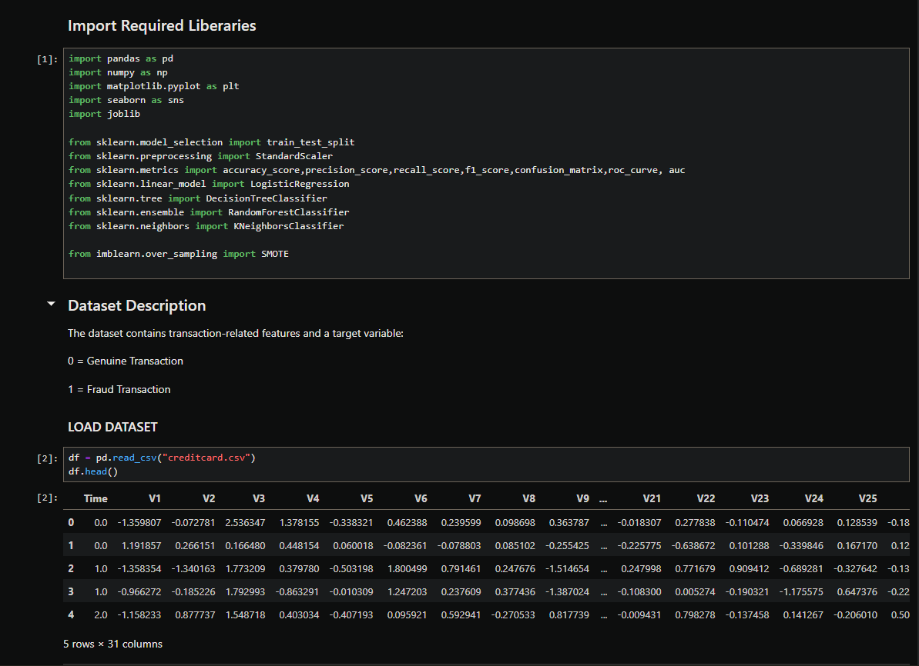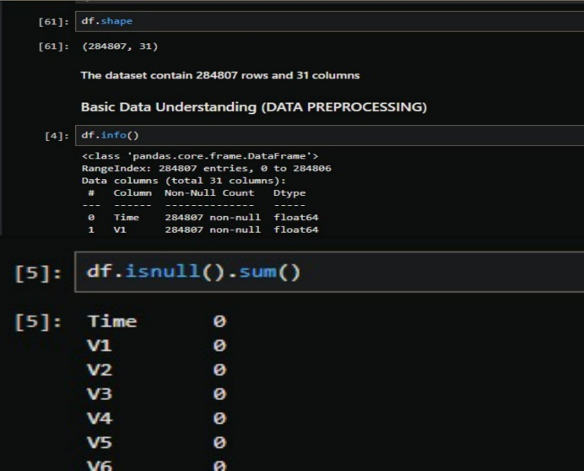
Figure 6.1 Figure 6.2

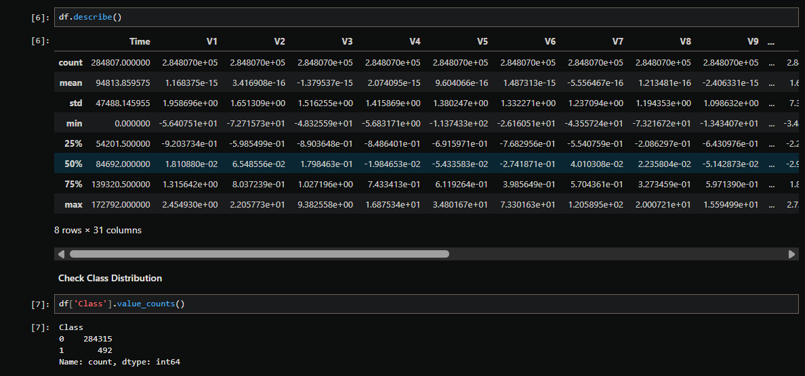
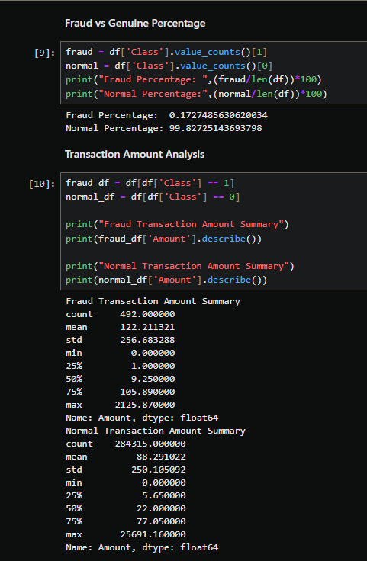
Figure 6.3 Figure 6.4
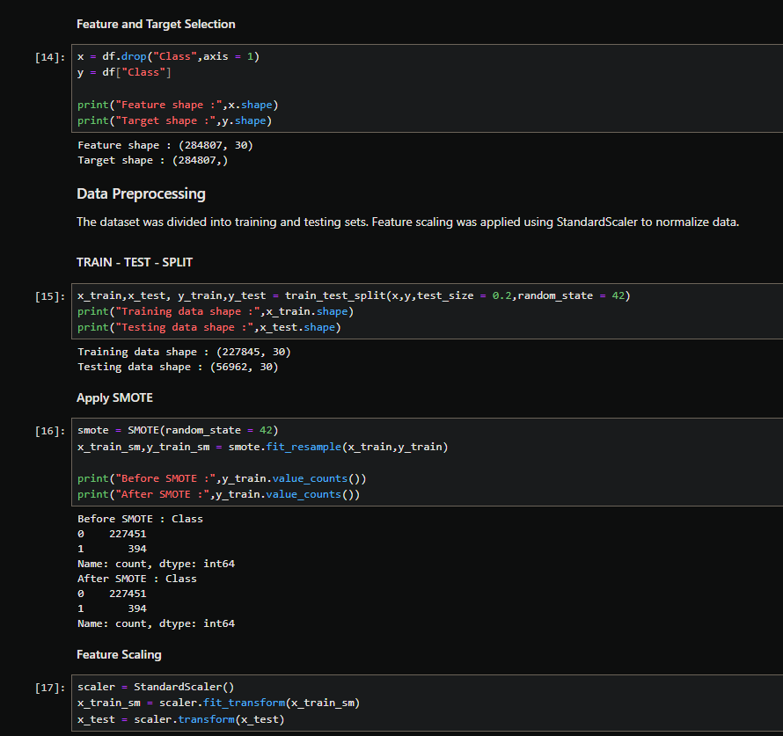
Figure 6.5

Explanation of Input Screens

Figure 6.1 – Importing Libraries and Loading Dataset
- The required Python libraries for data analysis and machine learning were imported successfully.
- Pandas and NumPy were used for data manipulation and numerical computation.
- Scikit-learn libraries were imported for model building and evaluation.
- The credit card transaction dataset was loaded using the read_csv() function.
- The dataset was stored in a DataFrame named df for further processing and analysis.

Figure 6.2 – Dataset Structure and Missing Value Analysis
- The dataset contains 284,807 records and 31 attributes.
- The df.info() function confirms that all columns are numerical in nature.
- The df.isnull().sum() function verifies that there are no missing values in any column.
- Since the dataset contains complete data, no imputation or data cleaning for null values was required.

Figure 6.3 – Statistical Summary and Class Distribution
- The df.describe() function provides a statistical overview of all numerical features in the dataset.
- It includes measures such as count, mean, standard deviation, minimum, 25th percentile, median (50%), 75th percentile, and maximum values.
- These statistics help in understanding the distribution and variability of transaction features.
- The class distribution analysis using value_counts() shows that the dataset is highly imbalanced.
- Genuine transactions significantly outnumber fraudulent transactions, indicating the need for special imbalance-handling techniques.

Figure 6.4 – Fraud Percentage and Transaction Amount Analysis
- The fraud and normal transaction percentages were calculated to understand class imbalance.
- Fraudulent transactions represent approximately 0.17% of the total dataset, while genuine transactions represent over 99%.
- Separate statistical summaries for fraud and normal transaction amounts were generated.
- This comparison helps identify differences in transaction behavior between fraudulent and genuine cases.
- Such analysis supports better feature understanding before model training.

Figure 6.5 – Feature Selection, Train-Test Split, SMOTE, and Feature Scaling
- The feature matrix (X) and target variable (y) were separated from the dataset.
- The dataset was split into training and testing sets using an 80:20 ratio.
- SMOTE (Synthetic Minority Over-sampling Technique) was applied to balance the minority fraud class in the training dataset.
- This helps improve the model’s ability to detect fraudulent transactions.
- Feature scaling was performed using StandardScaler to normalize the data.
- Scaling ensures that all features contribute equally during model training and improves algorithm performance.

Output Screen
The output section presents the results obtained after training and evaluating multiple machine learning models on the prepared dataset. Different classification algorithms were implemented to detect fraudulent transactions. The performance of each model was evaluated using metrics such as accuracy, confusion matrix, classification report, and ROC curve. Based on comparative analysis, the best-performing model was selected for final prediction.

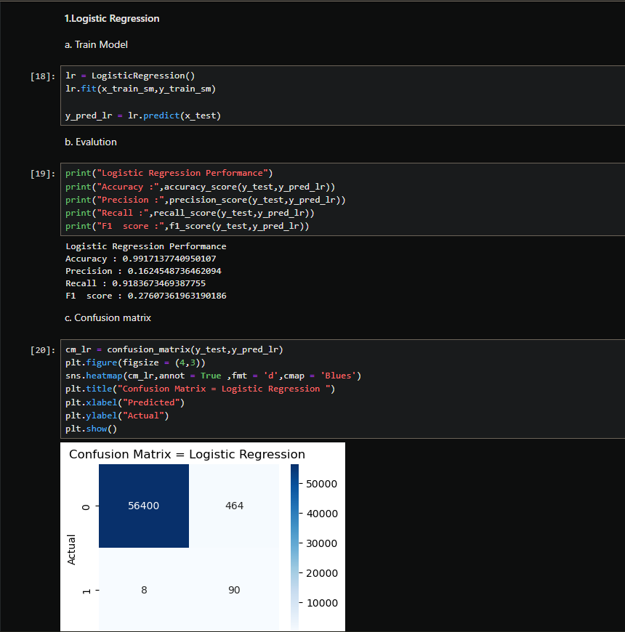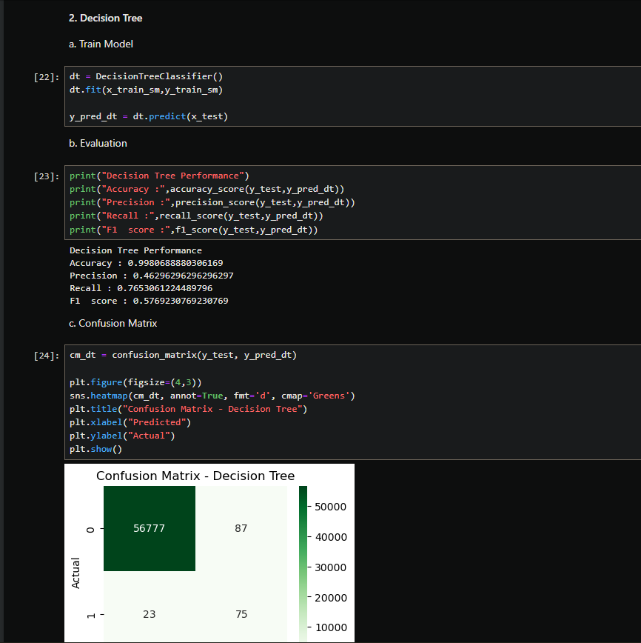
Figure 6.6 Figure 6.7

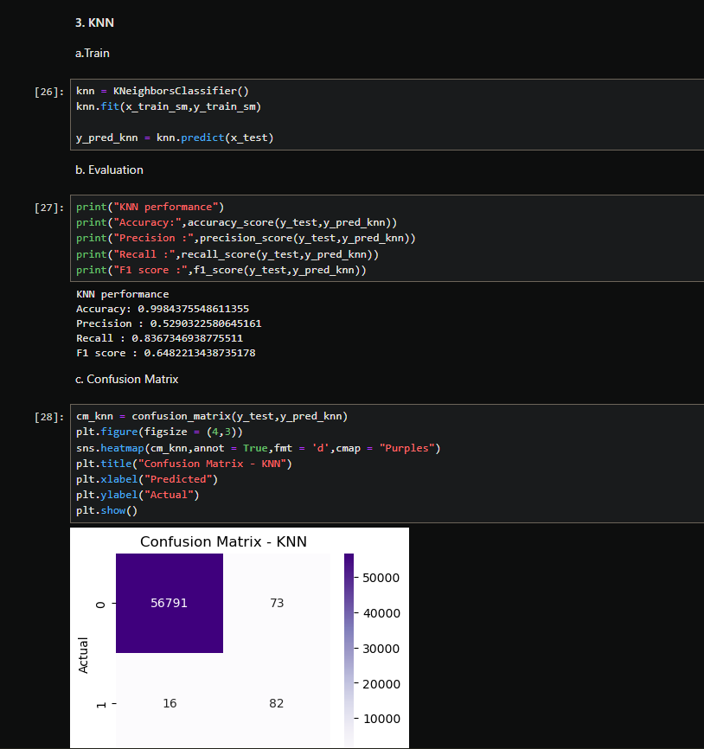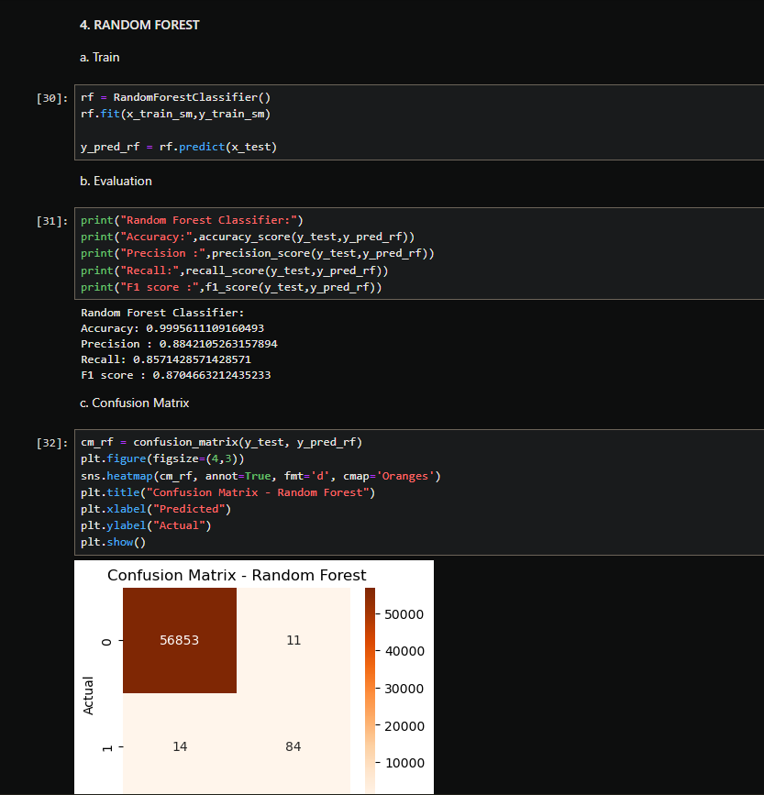
Figure 6.8 Figure 6.9

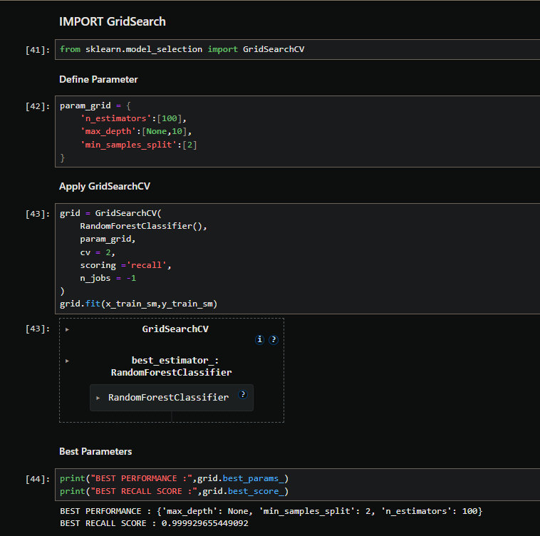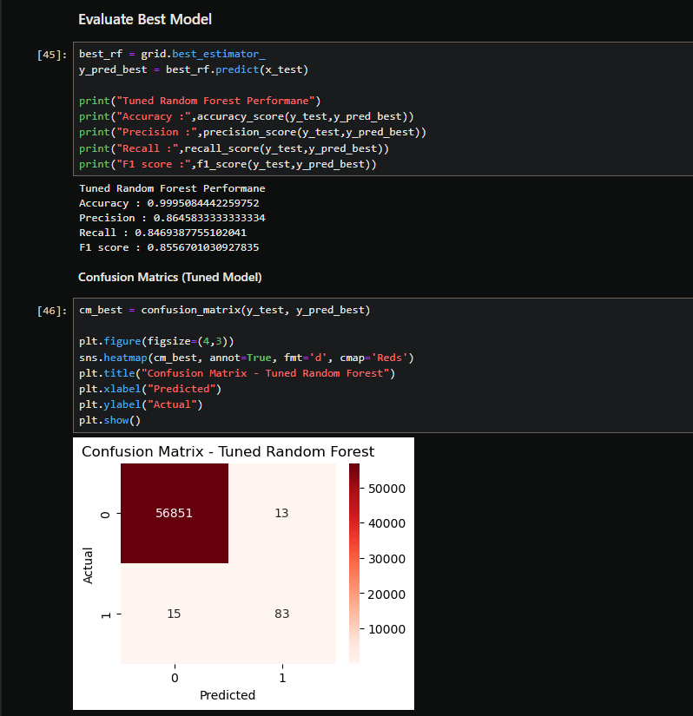
Figure 6.10 Figure 6.11

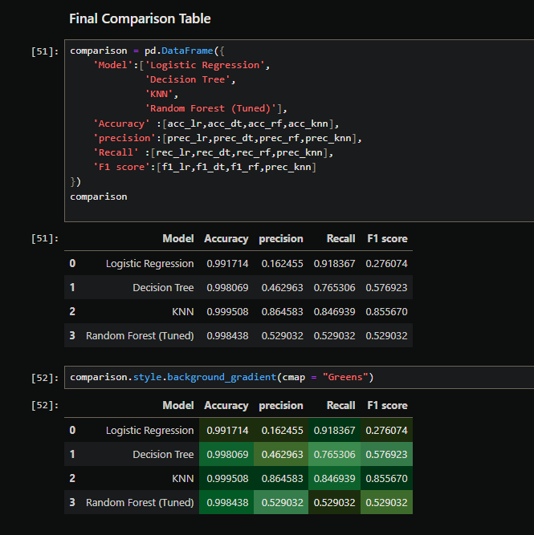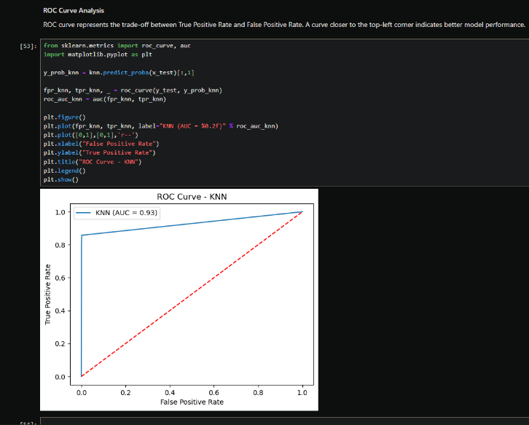
Figure 6.12 Figure 6.13

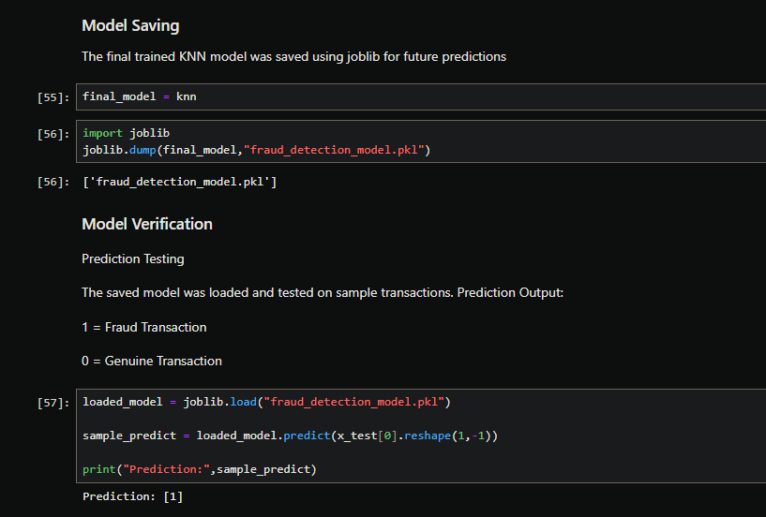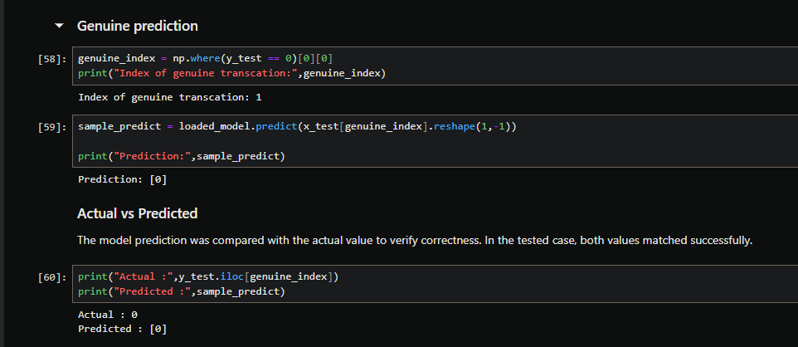
Figure 6.13 Figure 6.14

Figure 6.6 – Logistic Regression Output
- Logistic Regression model was trained on balanced dataset.
- The model achieved around 99% accuracy.
- Recall value was high, meaning most fraud cases were detected.
- Confusion matrix shows 56400 genuine correctly classified and 90 fraud correctly detected.
- Very few fraud transactions (8) were missed.

Figure 6.7 – Decision Tree Output
- Decision Tree model was trained and evaluated on test data.
- The model achieved nearly 99% accuracy.
- It captured non-linear patterns in the dataset.
- 56777 genuine transactions were correctly classified.
- 23 fraud transactions were missed.

Figure 6.8 – KNN Output
- KNN classifier was trained on scaled dataset.
- It achieved the highest accuracy (~99.95%) among all models.
- False positives and false negatives were very low.
- 56791 genuine and 82 fraud transactions were correctly classified.
- Due t its balanced performance in terms of precision, recall, and F1 score , KNN performed better than other models.

Figure 6.9 – Random Forest Output
- Random Forest classifier was trained using ensemble learning.
- It improved stability compared to Decision Tree.
- The confusion matrix shows high number of correctly classified transaction with minimal misclassification.
- 56853 genuine transactions were correctly classified.
- Only 11 false positives were observed.
- The model showed strong fraud detection capability.

Figure 6.10 – GridSearchCV (Hyperparameter Tuning)
- GridSearchCV was applied to optimize Random Forest parameters.
- Parameters like n_estimators and max_depth were tuned.
- Cross-validation was used to select the best model.
- The best recall score was achieved after tuning.
- This improved overall model efficiency.

Figure 6.11 – Tuned Random Forest Performance
- The optimized model was evaluated on test data.
- Accuracy and recall were recalculated.
- Confusion matrix shows improved fraud detection.
- False positives and false negatives were balanced.
- Tuned model showed better generalization.

Figure 6.12 – Final Model Comparison Table
- A comparison table was created for all models.
- Accuracy, Precision, Recall and F1-score were compared.
- Logistic Regression had high recall but lower precision.
- Among all models, KNN achieved the highest and most balanced performance , making it the best model for this project.
- This table helped in selecting the final model.

Figure 6.13 – ROC Curve Analysis
- The ROC curve was plotted to analyze the classification performance.
- ROC curve shows trade-off between True Positive Rate and False Positive Rate.
- Higher AUC value confirms that the selected model performs well in distinguished fraud and genuine transaction.
- KNN model achieved high AUC score.
- The curve is close to the top-left corner, indicating good performance.
- ROC confirms reliability of the selected model.

Figure 6.14 – Model Saving & Prediction Verification
- The final selected KNN model was saved using the joblib library as a .pkl file
- The saved model was loaded for testing.
- A sample transaction was selected for prediction.
- Predicted value matched the actual value.
- This confirms the correctness of the saved model.

CHAPTER 7: SKILLS DEVELOPED / LEARNING OUTCOMES
7.1 Technical Skill Acquired
The development of the Credit Card Fraud Detection System significantly enhanced various technical competencies related to data science, machine learning, and analytical programming.
One of the primary skills developed during this project was proficiency in Python programming for data analysis and machine learning applications. The project required the practical use of libraries such as Pandas for data manipulation, NumPy for numerical computations, Matplotlib and Seaborn for visualization, and Scikit-learn for machine learning model implementation. Through repeated experimentation and execution of code, a deeper understanding of syntax, functions, and object-oriented programming concepts in Python was achieved.
Another major technical skill acquired was data preprocessing and data cleaning. Working with a real-world dataset helped in understanding the importance of preparing data before feeding it into machine learning models.
This included:
- Loading and exploring large datasets
- Understanding dataset structure and dimensions
- Separating feature variables and target variables
- Performing train-test split for proper evaluation
- Normalizing data using StandardScaler
- Handling class imbalance using SMOTE
The implementation of SMOTE (Synthetic Minority Over-sampling Technique) provided valuable exposure to techniques used in handling imbalanced classification problems. This helped in understanding how model performance can be biased if class imbalance is not addressed properly.
The project also provided hands-on experience in implementing multiple supervised machine learning algorithms, including:
- Logistic Regression
- Decision Tree Classifier
- Random Forest Classifier
- K-Nearest Neighbors (KNN)
Each model was trained, tested, and evaluated separately. This process helped in understanding how different algorithms behave with the same dataset and how their strengths and weaknesses differ.

A significant technical enhancement was achieved in the area of model evaluation and performance analysis. Instead of relying only on accuracy, multiple evaluation metrics were used, including:
- Precision
- Recall
- F1-score
- Confusion Matrix
This helped in understanding the importance of selecting appropriate performance metrics, especially in fraud detection systems where detecting fraudulent transactions (recall) is more critical than overall accuracy.
Furthermore, practical experience was gained in hyperparameter tuning using GridSearchCV. By defining parameter grids and evaluating multiple combinations, knowledge was gained about optimizing model performance and selecting the best estimator.
Another important technical skill developed was model persistence and deployment readiness. The final trained model was saved using Joblib, which provided understanding of how machine learning models can be stored and reused for future predictions. This step introduced real-world deployment concepts.
Overall, this project strengthened practical implementation skills in data science, machine learning modeling, performance optimization, and result interpretation.

7.2 Problem-Solving and Critical Thinking
The project significantly enhanced analytical thinking and problem-solving abilities through various practical challenges.
One of the most critical problems encountered during the project was the class imbalance issue in the dataset. Fraudulent transactions were extremely rare compared to genuine transactions. This imbalance could lead to biased model predictions where the model predicts most transactions as genuine.
To address this issue, careful analysis of the dataset distribution was performed. After identifying the imbalance, SMOTE was applied to generate synthetic samples of the minority class. This decision required understanding of how imbalanced datasets affect recall and precision, and how oversampling techniques improve classification performance.
Another important challenge was selecting the most suitable machine learning algorithm. Instead of assuming one model to be best, multiple models were implemented and compared.

This required:
- Evaluating performance metrics of each model
- Comparing confusion matrices
- Understanding trade-offs between precision and recall
- Selecting the most balanced model
Critical thinking was applied while analyzing confusion matrices to understand:
- False positives
- False negatives
- Correct classifications

In fraud detection systems, false negatives (fraud predicted as genuine) are more harmful than false positives. Therefore, recall was given higher importance while evaluating models.
The hyperparameter tuning process also enhanced logical reasoning. By adjusting parameters such as number of estimators, maximum depth, and minimum samples split, the model performance was optimized. This required experimentation, comparison, and performance evaluation.
Time management and debugging were also important problem-solving aspects. Several errors such as shape mismatches, incorrect scaling, and parameter configuration issues were identified and resolved during the development process. These troubleshooting experiences strengthened logical debugging skills.
Overall, the project improved the ability to analyze real-world problems, evaluate multiple approaches, and implement the most effective solution using data-driven decisions.

7.3 Learning Outcomes
The completion of this project resulted in significant academic and practical learning outcomes.
Firstly, a clear understanding of how real-world fraud detection systems operate was achieved. The project demonstrated how financial institutions use machine learning algorithms to detect suspicious activities.
Secondly, the project bridged the gap between theoretical concepts and practical implementation. Concepts studied in machine learning theory such as supervised learning, classification algorithms, overfitting, evaluation metrics, and cross-validation were applied in a real dataset scenario.

The following learning outcomes were achieved:
- Ability to implement end-to-end machine learning workflow
- Understanding of data preprocessing techniques
- Knowledge of handling imbalanced datasets
- Practical implementation of multiple classification algorithms
- Evaluation of models using advanced performance metrics
- Optimization using hyperparameter tuning
- Understanding model comparison and selection
- Experience in saving and loading trained models
- Improved documentation and reporting skills

Additionally, the project enhanced confidence in working with large datasets and complex classification problems. It also improved analytical reasoning, interpretation of results, and decision-making based on statistical evidence.
The experience gained through this project will be beneficial for future work in data science, machine learning engineering, and real-world AI-based applications.
In conclusion, this project not only enhanced technical knowledge but also developed professional skills such as analytical thinking, problem-solving, research ability, and systematic implementation of machine learning solutions.

CHAPTER 8 : CHALLENGES FACED
8.1 Understanding Existing System
One of the major challenges faced during the development of the Credit Card Fraud Detection System was understanding the existing fraud detection mechanisms and traditional approaches used in financial institutions.

Initially, it was difficult to understand how real-world fraud detection systems operate. Financial institutions use highly complex systems involving rule-based engines, machine learning models, transaction monitoring systems, and real-time risk scoring. Understanding how these systems detect fraudulent behavior required detailed research and analysis.

Another challenge was understanding the structure and meaning of the dataset. The dataset contained anonymized features (V1, V2, V3, etc.), which made it difficult to interpret the actual significance of each variable. Since the original feature names were not available, it required careful study to understand how to treat them as input features without domain-specific assumptions.
Additionally, understanding the relationship between the target variable (Class) and the feature variables required exploratory data analysis. Identifying class imbalance, understanding data distribution, and interpreting statistical properties were initially challenging.

To overcome these difficulties:
- Research was conducted on fraud detection methodologies.
- Documentation and online resources were referred to understand classification problems.
- Exploratory Data Analysis (EDA) was performed to gain insights into the dataset.

Gradually, this improved understanding of how machine learning models can simulate fraud detection systems in a simplified environment.

8.2 System Complexity and Integration

Another major challenge faced during the project was managing system complexity and integrating different components into a single workflow.

The project required the implementation of multiple steps including:
- Data loading
- Data preprocessing
- Train-test splitting
- Handling imbalanced data using SMOTE
- Feature scaling
- Model training
- Hyperparameter tuning
- Model evaluation
- Model comparison
- Model saving and verification

Each step depended on the successful execution of the previous step. Even a small error in preprocessing could affect the final results. For example:
- Incorrect scaling could reduce model performance.
- Applying SMOTE incorrectly could cause data leakage.
- Using wrong evaluation metrics could mislead performance interpretation.

Integrating different machine learning models (Logistic Regression, Decision Tree, Random Forest, KNN) into a unified comparison framework was also challenging. It required careful tracking of predictions and evaluation metrics for each model.

Another difficulty was managing code structure and maintaining readability. As the notebook grew larger, organizing sections into logical blocks became important to avoid confusion.

To handle system complexity:
- The project was divided into structured sections.
- Proper comments were added in the code.

- Outputs were tested step-by-step.
- Intermediate results were verified before proceeding further.
This approach helped in building a systematic and well-integrated machine learning pipeline.

8.3 Adapting to New Technologies and Tools
Adapting to new technologies and tools was another significant challenge during the project development process.
Although theoretical knowledge of machine learning was available, practical implementation using Python libraries such as Scikit-learn, Imbalanced-learn, and Seaborn required hands-on practice. Understanding library syntax, function parameters, and model configurations required experimentation.
The implementation of GridSearchCV for hyperparameter tuning was initially complex. Defining parameter grids, selecting scoring metrics, and interpreting best parameters required careful learning and understanding.
Another technical challenge was using SMOTE (Synthetic Minority Over-sampling Technique). Understanding how synthetic samples are generated and ensuring that it is applied only to training data (to avoid data leakage) required careful attention.
Working with evaluation metrics such as precision, recall, and F1-score also required deeper understanding. Initially, accuracy seemed sufficient, but later it was realized that in fraud detection systems, recall plays a critical role. This required adapting the evaluation strategy accordingly.
Model persistence using Joblib was also a new concept. Learning how to save and reload trained models helped in understanding real-world deployment scenarios.

Throughout the project, several technical errors were encountered, including:
- Import errors
- Shape mismatch errors
- Incorrect parameter configurations
- Confusion in prediction reshaping
These errors required debugging, research, and repeated execution to resolve.
By continuously practicing, researching documentation, and experimenting with code, these challenges were successfully overcome. Adapting to these tools significantly improved practical knowledge and technical confidence.

CHAPTER 9 : CONCLUSION

The Credit Card Fraud Detection System project was successfully designed and implemented using machine learning techniques. The primary objective of the project was to build a reliable and efficient model capable of identifying fraudulent transactions from a large dataset of financial records.
Fraud detection is a critical problem in the financial sector, as fraudulent activities cause significant financial losses every year. Through this project, an attempt was made to simulate a real-world fraud detection system using supervised machine learning algorithms. The system was designed to analyze transaction data, detect suspicious patterns, and classify transactions as genuine or fraudulent.
The project followed a structured machine learning workflow, beginning with data loading and preprocessing. Exploratory data analysis helped in understanding the dataset structure and identifying the class imbalance issue. Since fraudulent transactions were significantly fewer compared to genuine transactions, the SMOTE technique was applied to balance the dataset and improve classification performance.
Multiple classification models were implemented, including Logistic Regression, Decision Tree, Random Forest, and K-Nearest Neighbors. Each model was evaluated using performance metrics such as Accuracy, Precision, Recall, F1-score, and Confusion Matrix. Instead of relying only on accuracy, special importance was given to Recall, as correctly identifying fraudulent transactions is more critical in fraud detection systems.
Hyperparameter tuning using GridSearchCV further improved model performance and helped in selecting the most optimized version of the algorithm. After comparison, the best-performing model was selected based on balanced performance metrics.
The final system demonstrated the ability to effectively classify transactions and provide meaningful evaluation results. The trained model was saved using Joblib, which makes it suitable for future deployment and real-time prediction use cases.
This project successfully bridged the gap between theoretical knowledge and practical implementation. Concepts learned in machine learning and data science were applied to a real-world problem, improving technical skills and analytical thinking abilities.
In conclusion, the Credit Card Fraud Detection System achieved its intended objectives. It provided valuable experience in handling imbalanced datasets, implementing classification algorithms, evaluating model performance, and optimizing machine learning solutions. The project not only enhanced technical expertise but also developed problem-solving skills required for real-world data-driven applications.

In addition to the successful implementation of machine learning models, the project also highlighted the importance of data-driven decision making in modern financial systems. Fraud detection systems must be accurate, fast, and reliable because even a small delay or incorrect prediction can lead to financial loss or customer dissatisfaction. Through this project, it was clearly understood that machine learning models play a vital role in improving security and minimizing risk in digital transactions.

The comparative analysis of multiple models helped in understanding that no single algorithm is universally perfect. Different algorithms perform differently depending on data characteristics. Therefore, model comparison and evaluation using multiple metrics is essential before selecting the final model. This practical experience provided a deeper understanding of model behavior and prediction patterns.
Another important achievement of this project was gaining confidence in implementing an end-to-end machine learning pipeline. From loading raw data to generating final predictions, every step was executed systematically. This structured workflow approach reflects how real-world machine learning projects are handled in industries.

The project also demonstrated the importance of preprocessing techniques such as scaling and balancing. Without proper preprocessing, model performance can decrease significantly. Thus, it became clear that data preparation is as important as model selection.
Furthermore, the experience gained in debugging errors and optimizing code contributed to improving programming efficiency and logical reasoning. Continuous testing and refinement of models helped in achieving better performance results.
Overall, this project has provided practical exposure to real-world problem solving using machine learning techniques. It has strengthened both theoretical understanding and implementation capability, preparing a strong foundation for future academic and professional growth in the field of data science and artificial intelligence.

CHAPTER 10 : REFERENCE / BIBLIOGRAPHY
The development of the Credit Card Fraud Detection System required extensive study of machine learning concepts, data preprocessing techniques, classification algorithms, and fraud detection methodologies. The following books, documentation, research materials, and online resources were referred to for understanding theoretical concepts and practical implementation.
- Géron, Aurélien. Hands-On Machine Learning with Scikit-Learn, Keras, and TensorFlow. 2nd Edition, O’Reilly Media, 2019.
This book was referred to for understanding practical implementation of machine learning models, model evaluation techniques, hyperparameter tuning, and handling real-world datasets using Scikit-learn.
- Alpaydin, Ethem. Introduction to Machine Learning. 3rd Edition, MIT Press, 2014.
This reference helped in understanding the theoretical foundation of supervised learning, classification algorithms, and model performance evaluation.
- Mitchell, Tom M. Machine Learning. McGraw-Hill Education, 1997.
This book was used to understand the core principles of machine learning, learning algorithms, and predictive modeling concepts.
- VanderPlas, Jake. Python Data Science Handbook. O’Reilly Media, 2016.
This resource provided guidance on data preprocessing, visualization techniques, and the use of Python libraries such as NumPy, Pandas, and Matplotlib.
- Scikit-learn Developers. Scikit-learn: Machine Learning in Python – Official Documentation. Available at: https://scikit-learn.org
The official documentation was referred to for understanding model implementation syntax, evaluation metrics, GridSearchCV, and pipeline creation.
- Imbalanced-learn Developers. Imbalanced-learn Documentation (SMOTE Technique). Available at: https://imbalanced-learn.org
This documentation helped in understanding the concept of handling imbalanced datasets and applying SMOTE correctly.

- Python Software Foundation. Python Official Documentation. Available at: https://docs.python.org
This source was used for understanding Python syntax, libraries, and debugging errors during implementation.
- Kaggle. Credit Card Fraud Detection Dataset.
The dataset used for this project was obtained from Kaggle, which provided anonymized transaction data for training and testing fraud detection models.
- GeeksforGeeks. Machine Learning and Data Science Tutorials. Available at: https://www.geeksforgeeks.org
This website was referred to for conceptual clarity on algorithms, evaluation metrics, and Python implementation examples.
- Various research papers and online articles related to Fraud Detection Systems and Classification Techniques were consulted to understand real-world applications and challenges in financial fraud detection.

